Overdale Community Primary School
Year 5 Autumn Term 1 - 2023

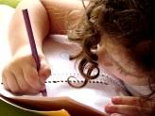  Literacy  In Year 5, will be looking at writing a warning story using speech to develop the story further as well as using fronted adverbials and varied sentences to leave our readers on a cliff hanger!  Year 5 will read Varjak Paw in whole class reading, focusing on vocabulary, inference, retrieval, prediction and summarising. | Maths  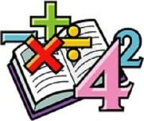  In maths, we will be working on place value, addition and subtraction and calculations involving statistics. We will also be continuing to learn and practise our times table skills, to make sure we are super at recalling them quickly and accurately. | Science  In science, this half-term, we are looking at the properties of materials. We will also be looking at how different materials dissolve in water and what it means by change of state. We will be conducting experiments to compare and group materials based on their properties. | Computing  In computing, Year 5 will be learning about online safety. We will revisit how to keep safe online and what to do if worries occur
Humanities  In history and geography, we will be travelling back to the time of the Ancient Greeks. We will be using our world map knowledge to locate and compare Greece to our country. We will be exploring the ancient Greeks famous cities, everyday life and work, fierce armies, amazing artists and inventors. | Our class book  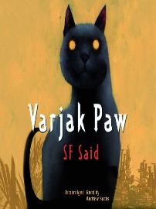 |  | 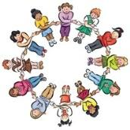  RHE/ PSHE  This term in RHE, Year 5 will be looking at family and relationships. We will discuss how to build and maintain positive friendships.  We will be engaging in respectful conversations and listening to one another’s opinions and views.
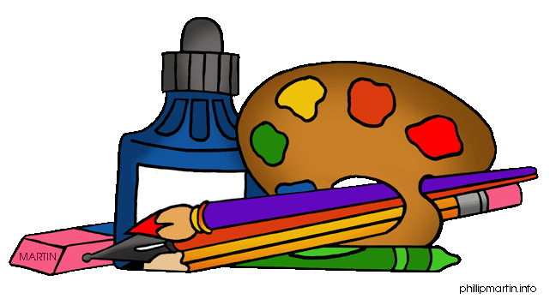  Art and DT  In DT, we will be looking at different types of structures.  In Art, we will be looking 'every picture tells a story'. Children will focus on understanding and creating abstract art.  Music –  This half term in music, Year 5 will be looking at composition through drumming sessions. | PE  This term in PE, we will be practising our leadership and team building skills to perform a piece of gymnastics and we will also begin to explore orienteering.  We will also have weekly swimming lessons on Mondays. | French –  In French, we will be brushing up on our French by learning how to pronounce common names for pets, to help us create our own French monster pet! | RE  In RE, we will be looking at a key question.  Why do some people think God exists?
Reading: Children will be expected to read their home reading books three times a week with a written comment/signature from a parent in their reading record. They will be given a reading record, which they will need to bring daily. Books will be changed when children complete a book review of their current reading book.
Maths: Children will be tested on their times tables at some stage throughout the week. Maths homework will be sent home to consolidate learning and continue to develop our understanding of a topic further.
Spelling: We will do a weekly spelling test every Friday. Children will be given a new spelling sheet to practise their spellings every week – this will need to be handed in every Friday. Homework club will be back up and running for children to attend and complete their homework with Mrs Meads/Miss Quinn.

